观察者模式
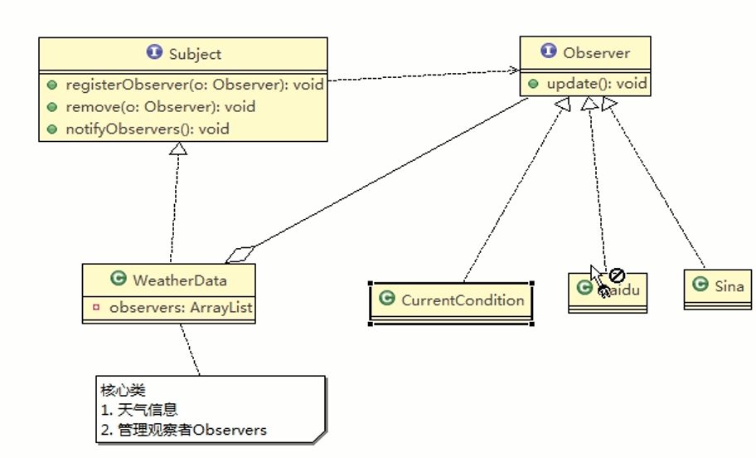

尝试一个spring的驱动模型
创建一个事件，监听者（Observer）会监听这个事件（Subject）。
public class SpringEvent extends ApplicationEvent {

@Getter
private String message;

public SpringEvent(ApplicationContext source, String message) {
super(source);
this.message = message;
}
}

- 创建一个监听者，基于泛型监听事件。
@Component
@Order(2)
public class SpringListener implements ApplicationListener<SpringEvent> {

@Async
@Override
public void onApplicationEvent(SpringEvent event) {
System.out.println(this.getClass() + String.format("收到事件，消息内容为[%s]",event.getMessage()));
try {
Thread.sleep(3000);
} catch (InterruptedException e) {
e.printStackTrace();
}
System.out.println(this.getClass() + "执行了监听");
}
}

- 发布事件，那么监听这类事件的监听者就会收到消息
@Service
public class TestService {

@Autowired
private ApplicationContext applicationContext;

void test(String meseage){
applicationContext.publishEvent(new SpringEvent(applicationContext,meseage));
System.out.println("事件发布完了");
}
}

使用applicationContext去发布，主要是通过了这一句：
getApplicationEventMulticaster().multicastEvent(applicationEvent, eventType);
获取这个上下文的事件广播者，然后去广播事件。然后去遍历所有的监听者，有哪些监听者是监听这类型的事件，找出来，然后去调用监听者的onApplicationEvent方法。

具体源码如下：
- 在创建beanfactory时，会初始化事件广播者。在AbstractApplicationContext的resresh()
@Override
public void refresh() throws BeansException, IllegalStateException {
synchronized (this.startupShutdownMonitor) {
。。。。。。。。。。。

try {
。。。。。。。。。。

// Initialize event multicaster for this context.
initApplicationEventMulticaster();

。。。。。。。。。。。
// Check for listener beans and register them.
registerListeners();

。。。。。。。。。。。
}

catch (BeansException ex) {
。。。。。。。。。。
}

finally {
。。。。。。。。。。
}
}
}

一个是初始化事件广播者，一个是在事件广播者上注册所有的监听者。
事件广播者的实现类：SimpleApplicationEventMulticaster
注册其实是保存在事件广播者的一个set集合里面。
public final Set<ApplicationListener<?>> applicationListeners;
具体源码点进去看。

- 然后发布事件。
protected void publishEvent(Object event, @Nullable ResolvableType eventType) {
Assert.notNull(event, "Event must not be null");

// Decorate event as an ApplicationEvent if necessary
ApplicationEvent applicationEvent;
if (event instanceof ApplicationEvent) {
applicationEvent = (ApplicationEvent) event;
}
else {
applicationEvent = new PayloadApplicationEvent<>(this, event);
if (eventType == null) {
eventType = ((PayloadApplicationEvent<?>) applicationEvent).getResolvableType();
}
}

// Multicast right now if possible - or lazily once the multicaster is initialized
if (this.earlyApplicationEvents != null) {
this.earlyApplicationEvents.add(applicationEvent);
}
else {
getApplicationEventMulticaster().multicastEvent(applicationEvent, eventType);
}

// Publish event via parent context as well...
if (this.parent != null) {
if (this.parent instanceof AbstractApplicationContext) {
((AbstractApplicationContext) this.parent).publishEvent(event, eventType);
}
else {
this.parent.publishEvent(event);
}
}
}
主要就是标红的那句，获取到事件广播者，然后调用multicastEvent方法。

这里执行分同步异步，案例有用注解表明。
@Override
public void multicastEvent(final ApplicationEvent event, @Nullable ResolvableType eventType) {
ResolvableType type = (eventType != null ? eventType : resolveDefaultEventType(event));
Executor executor = getTaskExecutor();
for (ApplicationListener<?> listener : getApplicationListeners(event, type)) {
if (executor != null) {
executor.execute(() -> invokeListener(listener, event));
}
else {
invokeListener(listener, event);
}
}
}

------------------------------------------------------------------------------------------------------------------------------------------------

protected void invokeListener(ApplicationListener<?> listener, ApplicationEvent event) {
ErrorHandler errorHandler = getErrorHandler();
if (errorHandler != null) {
try {
doInvokeListener(listener, event);
}
catch (Throwable err) {
errorHandler.handleError(err);
}
}
else {
doInvokeListener(listener, event);
}
}

------------------------------------------------------------------------------------------------------------------------------------------------

@SuppressWarnings({"rawtypes", "unchecked"})
private void doInvokeListener(ApplicationListener listener, ApplicationEvent event) {
try {
listener.onApplicationEvent(event);
}
catch (ClassCastException ex) {
String msg = ex.getMessage();
if (msg == null || matchesClassCastMessage(msg, event.getClass())) {
// Possibly a lambda-defined listener which we could not resolve the generic event type for
// -> let's suppress the exception and just log a debug message.
Log logger = LogFactory.getLog(getClass());
if (logger.isTraceEnabled()) {
logger.trace("Non-matching event type for listener: " + listener, ex);
}
}
else {
throw ex;
}
}
}

至此结束了。

